***Dt : 2/9/2022***

***Summary:***

***=>User Constructors we can load the data to object while object***

***creation process.***

***=>Using 'Setter methods' and 'Object_ref_variables' we can load***

***the data to Object after Object creation process.***

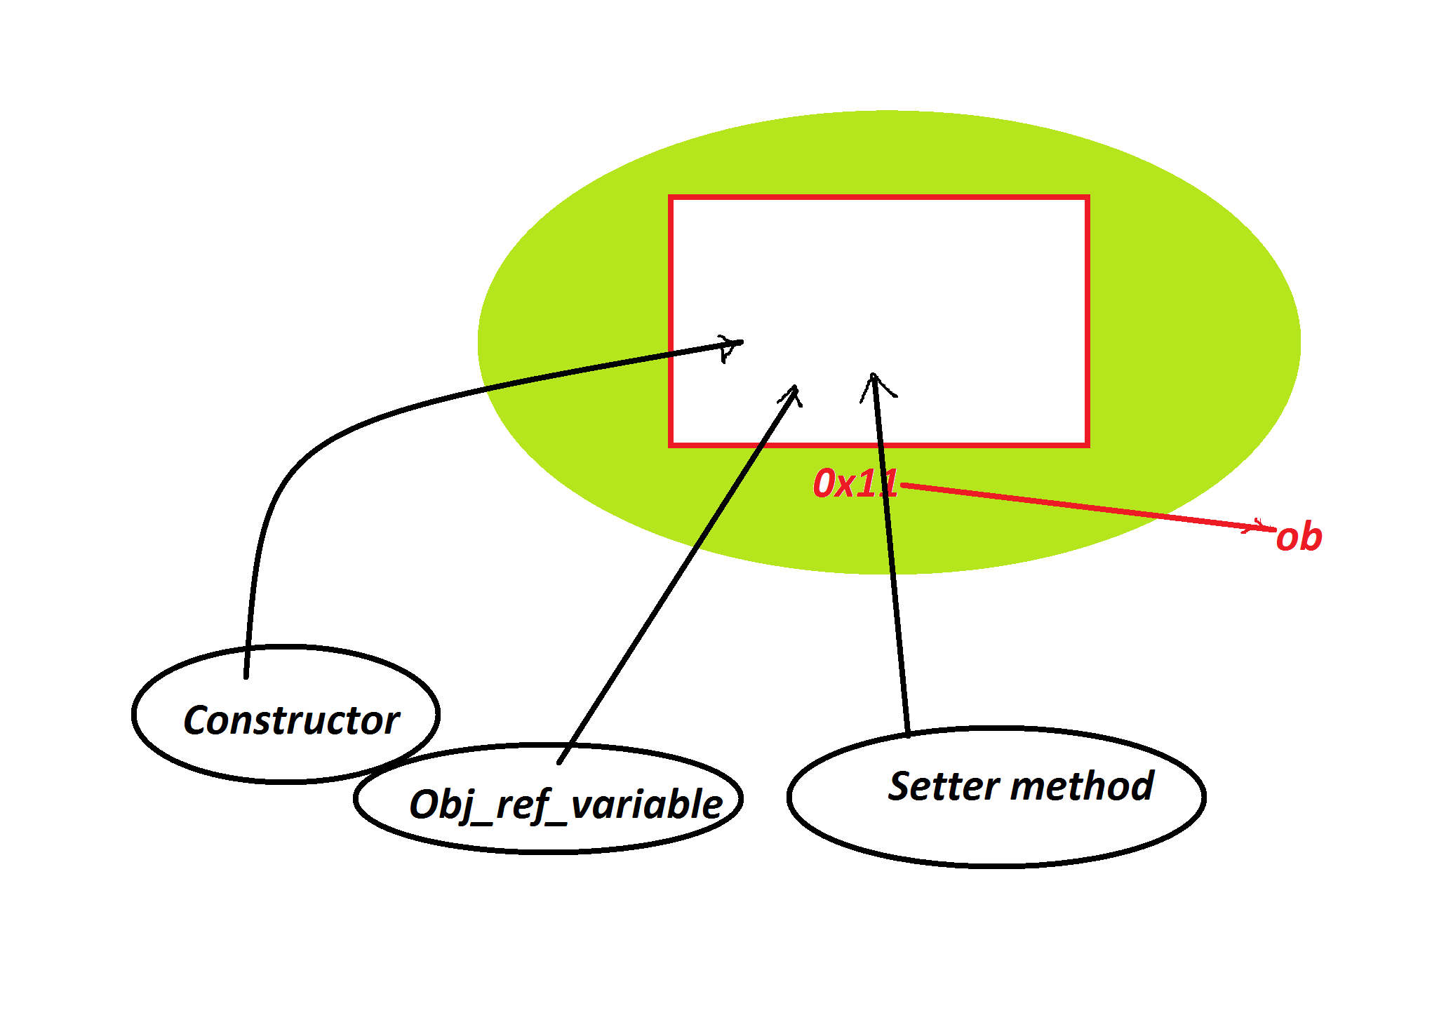

***====================================================***

***faq:***

***wt is the diff b/w***

***(i)Instance block***

***(ii)Constructor***

***=>Both components are executed while object creation process,but***

***Instance block will have highest priority in execution than***

***Constructor.***

***faq:***

***wt is the diff b/w***

***(i)static block***

***(ii)Constructor***

***=>static block is executed only once when the class is used for***

***the first time.(static block is executed while class loading)***

***=>constructor is executed only once while object creation process.***

***Ex : DemoCon5.java***

***class CTest //SubClass***

***{***

***static***

***{***

***System.out.println("====Static block====");***

***}***

***{***

***System.out.println("====Instance block====");***

***}***

***CTest()***

***{***

***System.out.println("====CTest() Constructor====");***

***}***

***}***

***class DemoCon5 //MainClass***

***{***

***public static void main(String[] args)***

***{***

***CTest ob = new CTest();***

***}***

***}***

***o/p:***

***====Static block====***

***====Instance block====***

***====CTest() Constructor====***

***========================================================***

***faq:***

***define default constructor?***

***=>The constructor without parameters which is added by the***

***compiler at compilation stage is known as default constructor.***

***faq:***

***In wt situation default constructor is added?***

***=>when compiler at compilation stage finds any class declared***

***witout constructors then default constructor is added.***

***==========================================================***

***Note:***

***=>Class can be declared with any number of constructors without***

***restriction,but the constructors are executed based on Con_call***

***available in Object creation syntax.***

***Ex : DemoCon6.java***

***class CTest //SubClass***

***{***

***CTest()***

***{***

***System.out.println("====0-para Con====");***

***}***

***CTest(int x)***

***{***

***System.out.println("=====1-para Con====");***

***System.out.println("The value x:"+x);***

***}***

***CTest(int y,int z)***

***{***

***System.out.println("=====2-para Con====");***

***System.out.println("The value y:"+y);***

***System.out.println("The value z:"+z);***

***}***

***}***

***class DemoCon6 //MainClass***

***{***

***public static void main(String[] args)***

***{***

***CTest ob1 = new CTest();//Con_Call_with_0_para***

***CTest ob2 = new CTest(12);//Con_Call_with_1_para***

***CTest ob3 = new CTest(13,14);//Con_Call_with_2_para***

***}***

***}***

***o/p:***

***====0-para Con====***

***=====1-para Con====***

***The value x:12***

***=====2-para Con====***

***The value y:13***

***The value z:14***

***================================================***

***faq:***

***wt is the behaviour of constructor declared with return_type?***

***=>If the constructor is declared with return_type then it is***

***considered as normal method.***

***Ex : DemoCon7.java***

***class CTest //SubClass***

***{***

***CTest()***

***{***

***System.out.println("====O-para====");***

***}***

***void CTest(int x)***

***{***

***System.out.println("====Instance method====");***

***System.out.println("The value x:"+x);***

***}***

***}***

***class DemoCon7 //MainClass***

***{***

***public static void main(String[] args)***

***{***

***CTest ob = new CTest();//Con_call***

***ob.CTest(12);//Method_call***

***}***

***}***

***=================================================***

***faq:***

***define Static Constructor?***

***=>There is no concept of static constructors in Java,which means***

***we cannot declare constructors with 'static' keyword.***

***Note:***

***=>Constructor means executed while object creation process and***

***which cannot be Class_level_component.***

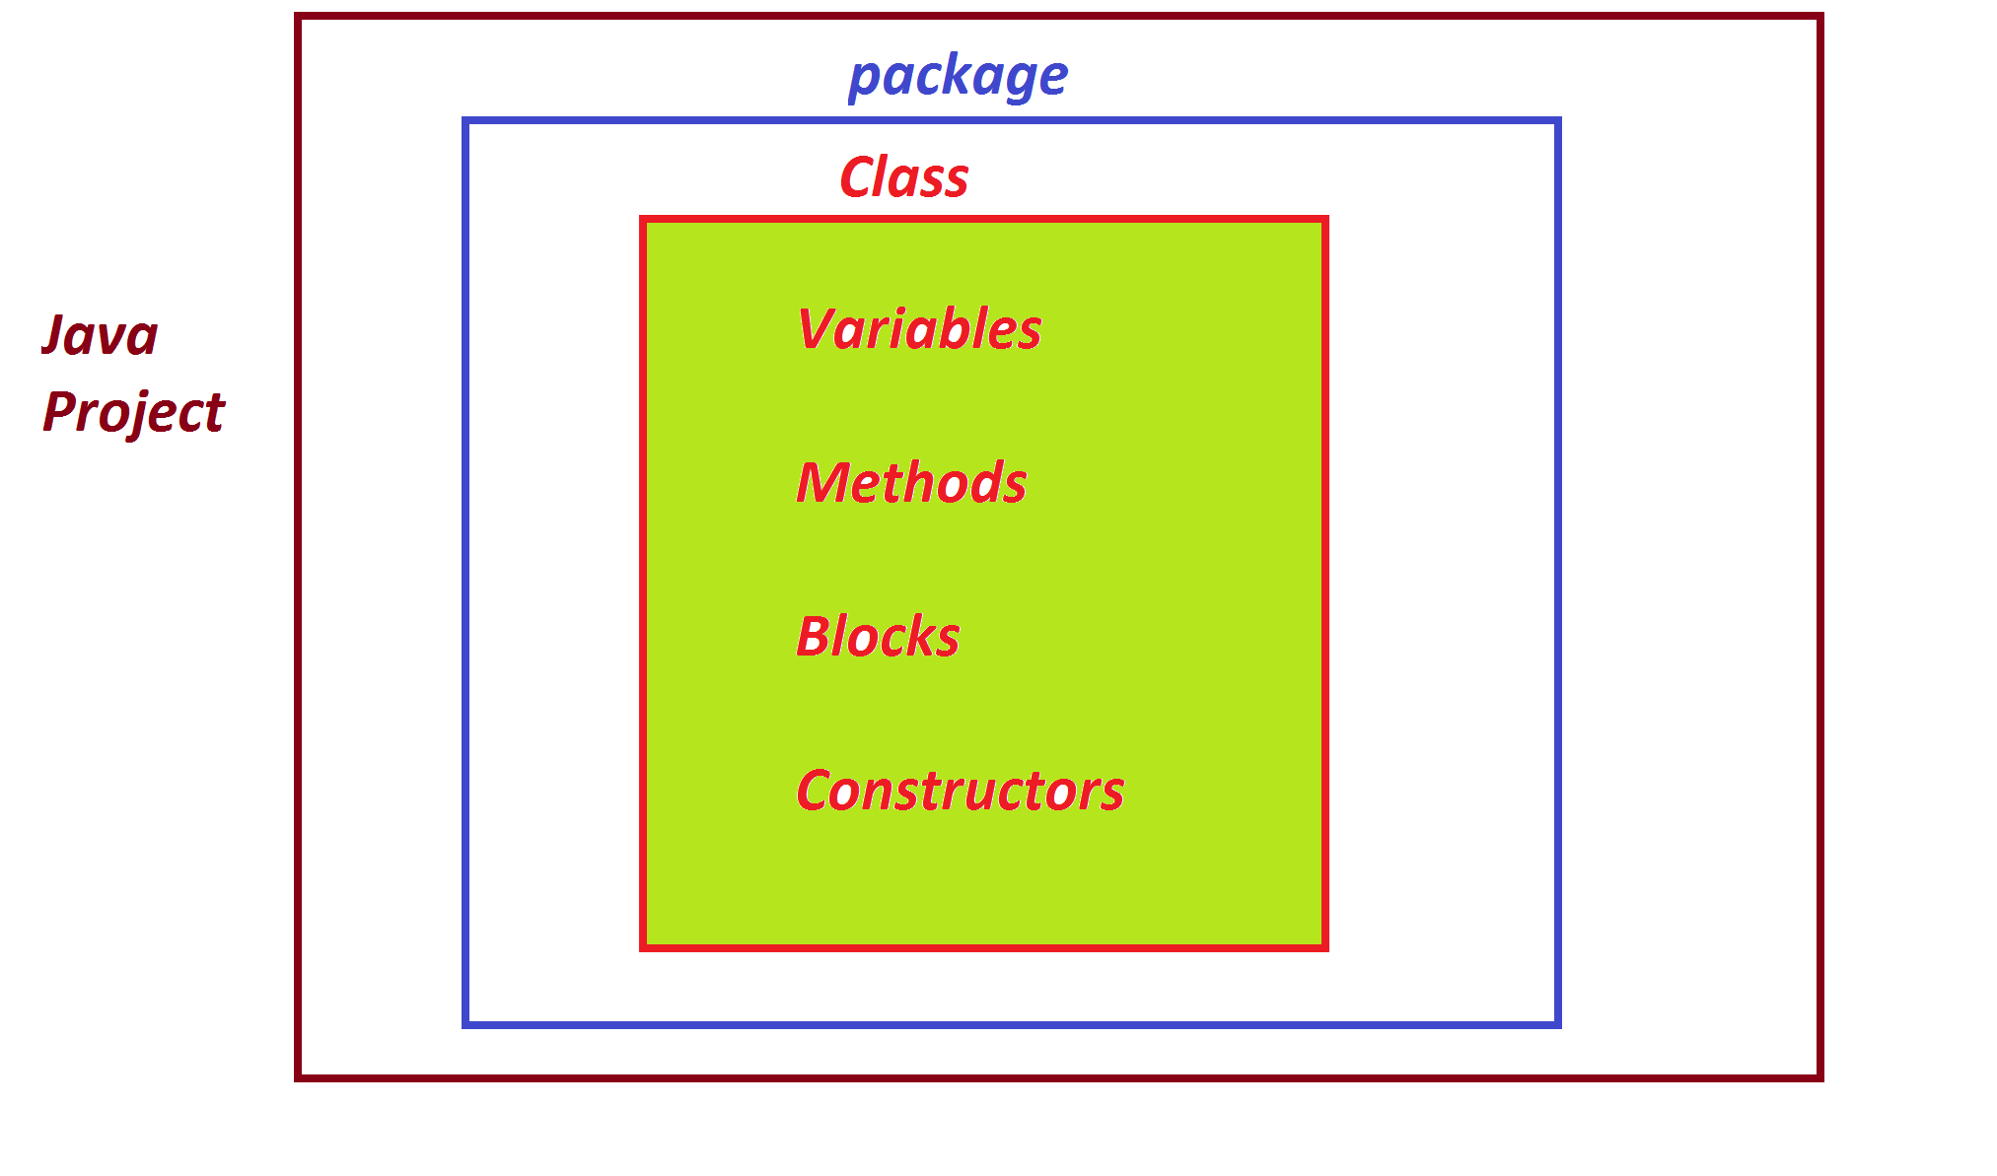

***====================================================***

***\*imp***

***Packages in Java:***

***=>Packages are collection of 'classes and Interfaces'.***

***=>packages are categorized into two types:***

***1.Pre-defined packages***

***2.User defined packages***

***1.Pre-defined packages:***

***=>The packages which are defined and available from JavaLib***

***are known as Pre-defined packages or Built-In packages.***

***=>The following are some important packages from JavaLib:***

***java.lang - Language package(default package)***

***java.util - Utility package***

***java.io - Input Output Streams package***

***java.net - Networking package***

***2.User defined packages:***

***=>The packages which are defined by the programmer are known***

***as User defined packages or Custom packages.***

***=>we use 'package' keyword to define User defined packages:***

***syntax:***

***package package_name;***

***=======================================================***

***Note:***

***=>DownLoad and Install IDE Eclipse using the following link:***

***https://www.eclipse.org/downloads/***

***Select : "Eclipse for Enterprise Java and Web"***

***========================================================***